**Need for Networking in Cloud**

* Our applications running on AWS Cloud needs to be accessed from internet and also there should some connectivity b/w servers in AWS 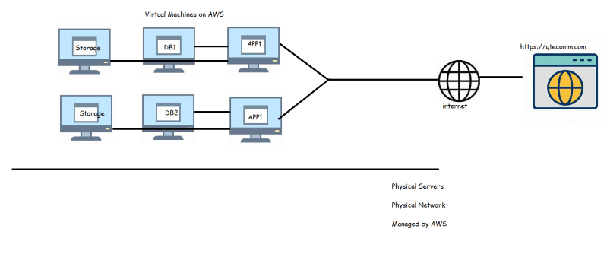
* So, for this we might need to manage a network which is virtual
* Establish secure private connections b/w on-premise and AWS 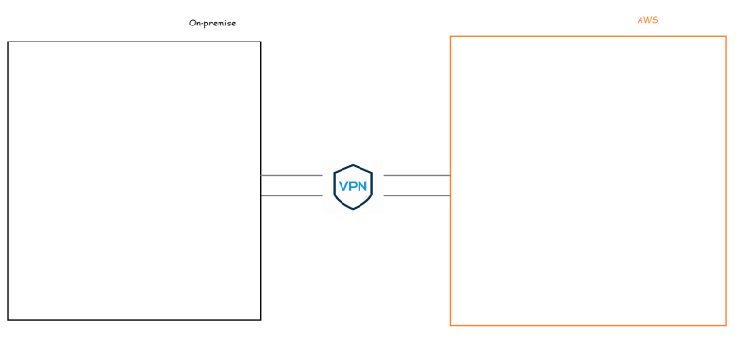

Understand Content Delivery Networks



* A content delivery network, or content distribution network, is a geographically distributed network of proxy servers and their data centers. The goal is to provide high availability and performance by distributing the service spatially relative to end users.
* Understanding DNS on cloud
* Load Balancers

**Networking Basics**

* IP Address:
  + Unique address given to a machine to establish connectivity.
  + Examples: 192.168.0.11, 10.100.2.4 and 35.25.26.11

There are two versions of IP address IPv4 and IPv6

IPv4:

* An IPv4 is made up of 32 bits, each with value of 0 or 1. We can have 4294967296 (2^32) possible Ip addresses
* Each IPv4 address is broken into 4 octets separated by a dot (.). Each octet has 8 bits 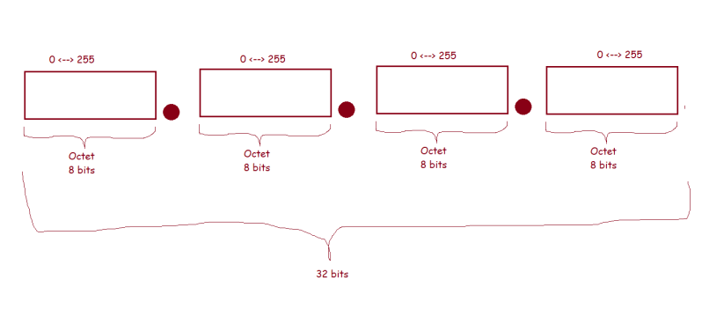

Now let’s find out ip address of our system 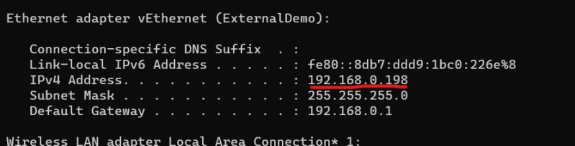

Questions to be answered

* Most of our system ip addresses start with 192.168.x.x (Why?)
* Most of system ip addresses in organization will be 10.x.x.x (why)
* What is purpose of subnet mask and Default Gateway

Let’s try to convert IP addresses from decimal to binary

192.168.0.198 decimal

11000000.10101000.00000000.11000110 binary

10.0.1.4 decimal

00001010.00000000.00000001.00000100 binary

172.16.0.7 decimal

10101100.00010000.00000000.00000111

Each ip address has

* network id: unique id for the network
* host id: unique id for the host

To find network id and host id we need subnet mask

ip: 192.168.0.198

sm: 255.255.255.0

network id: 192.168.0

3 octets

host id: 198

1 octet

ip: 10.11.20.25

sm: 255.255.0.0

network id: 10.11

2 Octets

host id: 20.25

2 Octets

Number of octets in host id represent number of devices network connect

ip: 192.168.0.198

sm: 255.255.255.0

network id: 192.168.0

3 octets

host id: 198

1 octet => 2^8 ~= 256

ip: 10.11.20.25

sm: 255.255.0.0

network id: 10.11

2 Octets

host id: 20.25

2 Octets => 2^16 ~= 65536

One more example

ip: 172.16.0.8

sm: 255.0.0.0

network id: 172

1 octet

host id: 16.0.8

3 Octets => 2^24 ~= 16777216